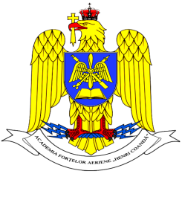

ROMANIA
MINISTRY OF NATIONAL DEFENSE
“Henri Coanda”
AIR FORCE ACADEMY

INTERNATIONAL WEEK
21 – 25 March, 2022

Please fill in the form and send it by 15th January 2022, to:
- LtCol Cosmina-Oana ROMAN, PhD, Vice-Rector for Programs and International Relations at “Henri Coandă” Air Force Academy: roman.cosmina@afahc.ro

Delegation info:

Country
Academy/Institution
 | ESCORT OFFICER | CADET 1 | CADET 2
First name

Last name

Rank

Gender

Cell phone number, with country code
Personal e-mail address
Passport number and
date of expiry
Food allergy or special diet

TRAVEL PLANS
 | Date | Time |  | Flight/train number | Location/Airport
- Arrival information
- Departure information

Any comment or special request: ……………………………………………………………… ……………………………………………………..........................................................................................................................................................................................................................................

